Amazon Customer Support Chatbot
Naan Mudhalvan Project Report
Name: Mahalakshmi.N , Harini.V , Mounysha.S
Register Number: 311655505035 , 311655505019 , 311655505037
Department: Information Technology
Institution: Misrimal Navajee Munoth Jain Engineering College
Date:

Introduction
Customer service is a crucial aspect of any e-commerce platform. Chatbots are increasingly used to automate basic queries and reduce human workload. In this project, we create a chatbot that handles various customer inquiries regarding Amazon orders using Python, NLTK, and a CSV dataset.

Literature Review
Natural Language Processing (NLP) allows computers to understand human language. Libraries like NLTK simplify the development of chatbots using pattern matching and rule-based responses. Several e-commerce platforms use AI-based assistants to improve user experience, and this project demonstrates a basic implementation of such technology.

System Design
Architecture Diagram:
User Input → NLTK Chat Module → Pattern Matching → Response Generation → Output
Components:
- User Input: Input received from the user
- NLTK Chat: Handles pattern matching and response selection
- CSV Dataset: Stores pattern-response pairs for easy customization
- Response Output: Display of appropriate chatbot reply

Implementation
Technologies Used:
- Python
- NLTK
- Pandas

PROGRAM:
# === Import Required Libraries ===

import nltk
# NLTK (Natural Language Toolkit) is a powerful Python library for natural language processing.
# We use it here to build a simple chatbot using regex pattern matching.

from nltk.chat.util import Chat, reflections
# Chat: A utility from NLTK that helps build a rule-based chatbot using pattern-response pairs.
# reflections: A predefined dictionary for common conversational word swaps (e.g., "I am" → "you are").

import pandas as pd
# pandas is used for data manipulation.
# We use it here to read the chatbot patterns and responses from a CSV file.

# === Load Dataset from CSV ===

df = pd.read_csv("C:\\Users\\maham\\Downloads\\amazon_chatbot_dataset.csv")
# Reads the chatbot data from the specified CSV file into a DataFrame.
# The CSV file should have at least two columns: 'pattern' and 'response'.

# === Convert DataFrame to List of Pattern-Response Pairs ===

pairs = []
# Initialize an empty list that will hold all the chatbot pattern-response pairs in the format NLTK expects.

for index, row in df.iterrows():
# Loop through each row in the DataFrame.

pairs.append([
row['pattern'],
# 'pattern' column should contain regex or text input the user might type.

[row['response']]
# 'response' column contains the chatbot's reply.
# Wrapped in a list because NLTK's Chat expects a list of possible responses.
])

# === Create the Chatbot ===

chatbot = Chat(pairs, reflections)
# Initialize the chatbot using the pattern-response pairs and reflections for word substitution.
# Now, the chatbot is ready to take input and provide relevant answers.

# === Define Chatbot Interaction Function ===

def start_chat():
# This function starts the chatbot interaction with the user in the command line.

print("Hello! I'm your Amazon customer support bot. Type 'bye' to exit.")
# Welcome message to the user.

while True:
# Infinite loop to keep the chatbot running until the user types a termination keyword.

user_input = input("You: ")
# Get input from the user via the terminal.

if user_input.lower() in ["bye", "exit", "quit"]:
# Check if the user wants to end the chat (case-insensitive check).

print("Chatbot: Thank you for contacting Amazon Customer Support. Have a great day!")
# Exit message.

break
# Exit the while loop and stop the chat.

response = chatbot.respond(user_input)
# Use the Chat object to match the user input with the appropriate pattern and get the response.

print(f"Chatbot: {response}")
# Display the chatbot's response.

# === Run the Chatbot Script ===

if __name__ == "__main__":
# Check if this script is being run directly (and not imported as a module somewhere else).

start_chat()
# Start the chatbot conversation by calling the function.

OUTPUT:

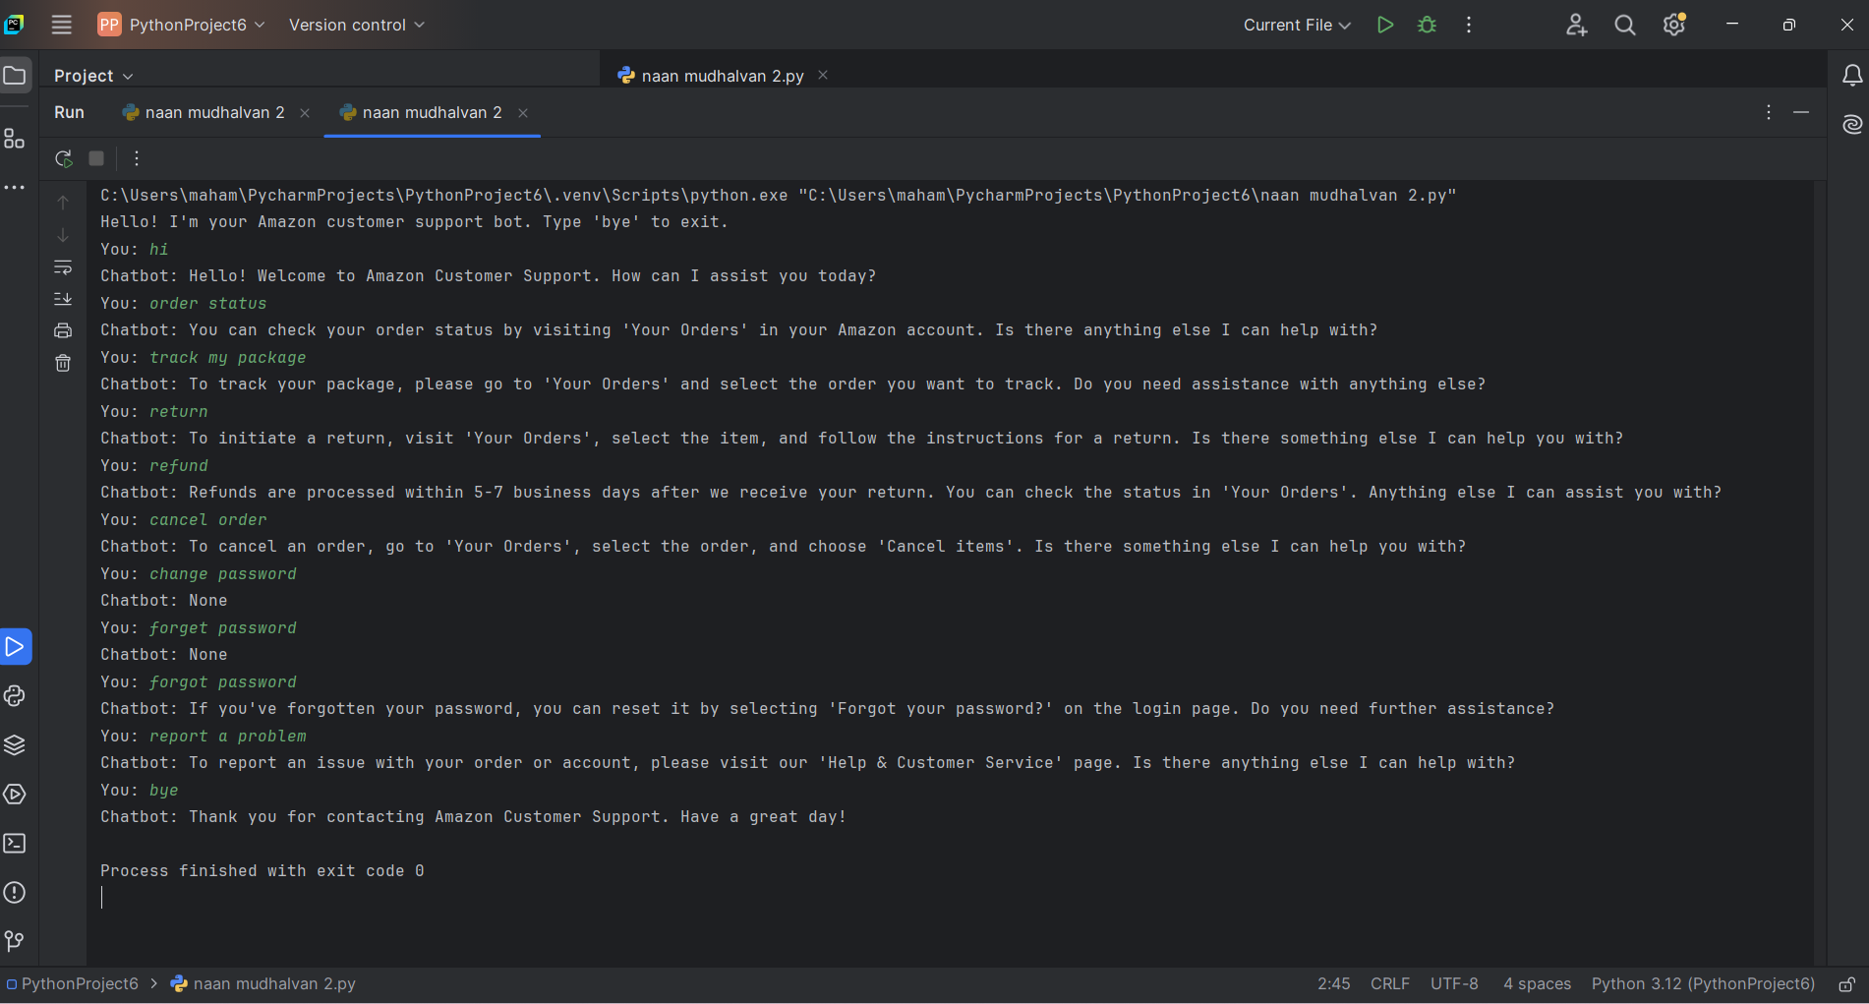

Package/Command | Installed/Imported | Purpose/Functionality
nltk | Installed via pip install nltk | Natural Language Toolkit (NLTK) - used for natural language processing.
from nltk.chat.util import Chat, reflections | Imported from nltk.chat.util | Chat: Manages the conversation logic using patterns and responses.  reflections: A predefined dictionary for basic input-output reflections (like "I am" → "you are").
pairs = [...] | User-defined in code | Defines a list of patterns (regular expressions) and responses for the chatbot.
chatbot = Chat(pairs, reflections) | Initialized in code | Creates a Chat object with the predefined patterns and reflection mappings.
start_chat() | User-defined function | Starts the chat loop: waits for user input, processes it, and provides a chatbot response.
input() | Python built-in function | Accepts user input during the chat session.
chatbot.respond(user_input) | Chat method | Matches user input against patterns and returns an appropriate response.
if __name__ == "__main__": start_chat() | Python entry point check | Ensures the chatbot runs only when the script is executed directly (not when imported).

